

**Faculty of Engineering**

**School of Computer Science**

**2022-2023**

**Mentor: Vishal Pawar**

**SYNOPSIS**

**ON**

**Topic**

**BY**

Team Member

1. Joel Randive (03)
2. Vipul Doiphode(62)
3. Omkar Sawant (26)
4. Shivam Satav (38)
5. Aditi Akadkar (40)

**MASTERS OF COMPUTER SCIENCE**

**DATA SCIENCE AND BIG DATA ANALYTICS**

**Dr. Vishwanath Karad MIT- World Peace University**



**INDEX**

|  |  |  |
| --- | --- | --- |
| **Sr. No.** | **Contents** | **Page No.** |
| **Chapter 1** | **INTRODUCTION** |  |
| * 1. Problem Statement |  |
| 1.2 Study of Work Done so far |  |
| **Chapter 2** | **PROPOSED DATA SET TO BE USED** |  |
| 2.1 Sample Data (10 Observations) |  |
| 2.2 Process of Data collection |  |
| 2.3 References for Data Collection |  |
| **Chapter 3** | **ANALYSIS AND DESIGN** |  |
| 3.1 Proposed Model Solution |  |
| 3.2 Proposed Technologies to be Used |  |
| 3.3 Proposed Architecture Solution (Diagrams) |  |
| **Chapter 4** | **SCOPE** |  |
| 4.1Scope of Project  4.2 References |  |

**Chapter 1**

**Problem statement:**

Identification of the plant diseases is the key to preventing the losses in the yield and quantity of the agricultural product. The studies of the plant diseases mean the studies of visually observable patterns seen on the plant. Health monitoring and disease detection on plant is very critical for sustainable agriculture. It is very difficult to monitor the plant diseases manually. It requires tremendous amount of work, expertise in the plant diseases, and also require the excessive processing time. Hence, image processing is used for the detection of plant diseases. Disease detection involves the steps like image acquisition, image pre-processing, image segmentation, feature extraction and classification. The occurrence of plant diseases has a negative impact on agricultural production. If plant diseases are not discovered in time, food insecurity will increase . Early detection is the basis for effective prevention and control of plant diseases, and they play a vital role in the management and decision-making of agricultural production. In recent years, plant disease identification has been a crucial issue.

**Study of work done so far:**



In recent years, deep learning technology in the study of plant disease recognition made more progress. Deep learning (DL) technology in the face of the user is transparent, the researchers of plant protection and statistics professional level is not high, can be automatically extracted image features and classification of plant disease spot, eliminating the traditional image recognition technology of feature extraction and classifier design a lot of work, can express original image characteristics, has the characteristics of the end-to-end. These characteristics make deep learning technology in plant disease recognition-obtained-widespread attention This is due to three factors: the availability of larger datasets, the adaptability of multicore graphics processing units (GPUs), and the development of training deep neural networks and supporting software libraries, such as the computing unified device architecture (CUDA) from NVIDIA.

**PROPOSED DATA SET TO BE USED**

2.1 Sample Data (10 Observations)

For the model training phase the data is taken from kaggle. By using python,cv2,keras,numpy,tensorflow the image is manipuated , preprocessed and made ready for the modelling phase.

The plant disease as the following classes in which the crop will be classified:

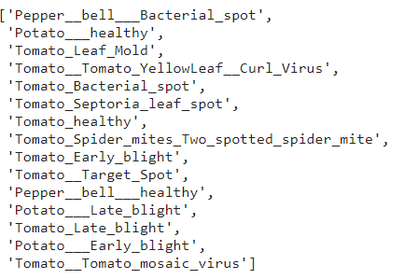

The following is the sample of the entire Image dataset which shows Tomato_Bacterial_spot .

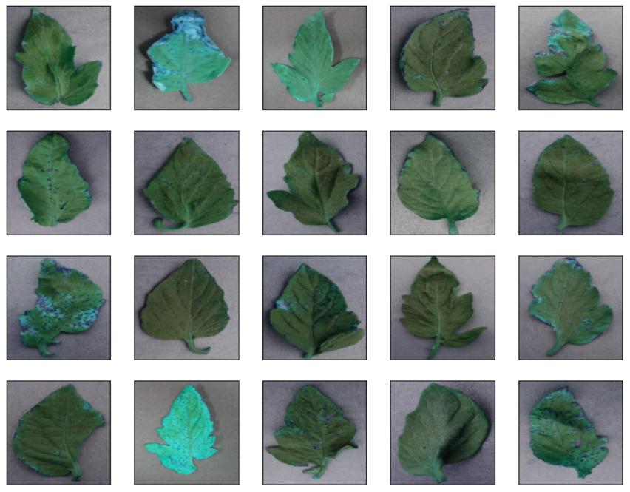

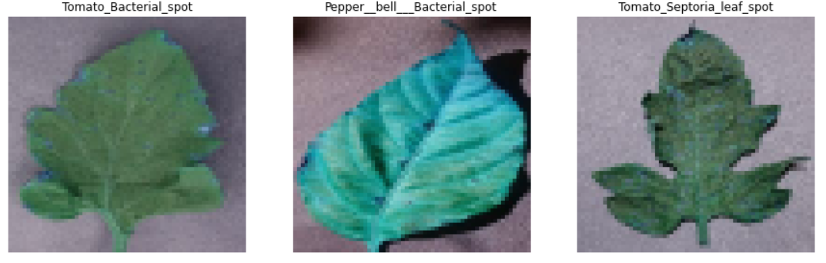

For validation using the android application made using react-native we can scan the crop using the phone’s camera

Proposed Model Solution:

Using the CNN(Convolutional Neural Network) and using the DenseNet as the head in the Transfer Learning and using SVM as the classifier.Having 256 neurons in the hidden layer , and 15 neurons at the output layer for 15 image classes with a softmax activation function. Using Adam as an optimizer .

Proposed Technologies to be Used:

Using React-native for the building an android application where in the farmer can scan the photo of the crop , moving on the image will move forward through the pipeline which is image pre-processing phase which will make use of computer vision- python(keras,tensorflow). After the pre-processing phase , the preprocessed image will be ready for the modelling phase in where the image will be run through the model. The model consist of transfer learning technique , GoogleNet is used as a base and SVM as the classifier.

3 Proposed Architecture Solution (Diagrams):

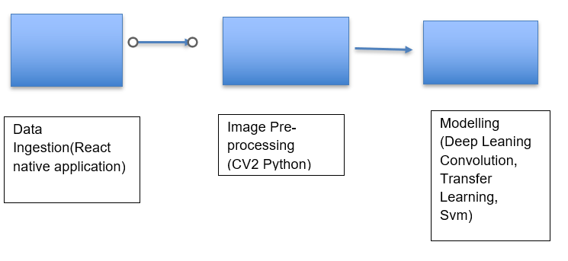

4.1Scope of Project:

Disease detection, quantification, classification and prediction are such challenging domains as they contain many varying parameters. Due to its vast, unpredictable nature inclusion of the latest machine learning and big data techniques will be a major improvement and an obvious evolution. There are many challenges still in the field of plant disease diagnosis using image processing and computer vision. In the recent review papers, we found out there are many potentials areas such as work on 3D images are still not so prevalent. Talking about deep learning, the predictive and probabilistic model generation from the already existing data is one of the significant advantages of it, and hence it is quite efficient regarding plant growth and disease prediction, identification, classification and quantification. There are some farming practices in the picture, which gives a huge potential for future endeavours such as zero-budget farming. With the use of open-source software development in the field of computer vision and machine learning along with the conventional and newly evolved farming practice, we may achieve fruitful results for the betterment of the society. Free distribution and sharing of the data will also benefit and facilitate the research work in this domain.

4.2 References:

<https://www.frontiersin.org/articles/10.3389/fpls.2016.01419/full>

<https://www.researchgate.net/publication/314436486_An_Overview_of_the_Research_on_Plant_Leaves_Disease_detection_using_Image_Processing_Techniques>

<https://plantmethods.biomedcentral.com/articles/10.1186/s13007-021-00722-9>